Dmitrii Ponomarev

Ec22805@qmul.ac.uk

Abstract

This analysis provides insights into incident data collected from all New York boroughs. It contains data about crashes that injure and takes life of pedestrians, cyclists, and people in other vehicles.[TK]

New york crash analysis

# Introduction

## Description

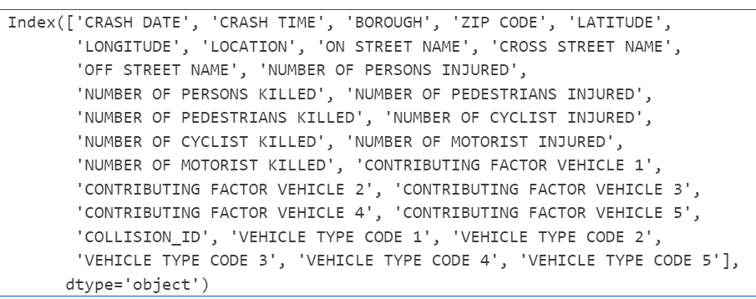

Figure - Columns of the dataset

## Hypothesis

1. The average number of incidents doesn’t vary significantly across different days of the month
2. The average number of incidents doesn’t vary significantly across different hours of the day
3. The average number of incidents doesn’t vary significantly across boroughs
4. The density of incidents distributed the same across New York

# Analysis

# Conclusion

# Table of contents

# Table of figures

# References